A MINI PROJECT REPORT ON
SMART PERSONAL ASSISTANT AGENT
(An Agentic Artificial Intelligence Mini Project)
Submitted in partial fulfillment of the requirements for
AGENTIC AI
Submitted by
HARSHA SRI DODDI
23U41A4411
CSDM- DATA SCIENCE
DADI INSTITUTE OF ENGINEERING AND TECHNOLOGY
Academic Year 2023-2027

Abstract
This project presents the design and implementation of a Smart Personal Assistant Agent — a beginner-level demonstration of Agentic Artificial Intelligence built using Python. Unlike conventional programs that execute one fixed task, an intelligent agent autonomously perceives a user's natural-language request, reasons about which action is appropriate, executes that action using the correct tool, and returns a relevant response.
The proposed system integrates four independent tools — a calculator, a date-and-time utility, a to-do list manager, and a Wikipedia knowledge-search module — under a single decision-making engine that selects the correct tool based on user intent. The project illustrates the foundational Perceive → Decide → Act → Respond loop that underlies modern agentic AI systems, including the advanced LLM-based agents that power today's AI assistants and chatbots.

1. Introduction

1.1 Background
Artificial Intelligence has evolved from simple rule-based programs to autonomous, goal-driven agents capable of independent decision-making. In AI terminology, an “agent” is any system that perceives its environment through inputs, reasons about the best course of action, and acts upon that environment to achieve a goal. “Agentic AI” specifically refers to systems that exhibit autonomy — they decide for themselves what action to take, rather than simply following one hardcoded instruction path.

1.2 Motivation
Most beginner programming projects (a calculator, a to-do app, a search tool) are single-purpose. In real life, however, a useful personal assistant must handle many different kinds of requests through ONE interface, deciding for itself how to respond to each. This project bridges that gap by combining multiple tools under one intelligent decision-making layer, giving hands-on experience of how agent-based AI systems function internally.

2. Objectives
- To understand and implement the core agentic AI loop: Perceive → Decide → Act → Respond
- To design a multi-tool agent capable of handling diverse user requests through a single interface
- To implement independent tool modules: calculator, clock, to-do manager, and knowledge search
- To build a decision engine that autonomously selects the correct tool from natural language input
- To demonstrate the foundation on which modern LLM-based AI agents are built

3. System Requirements

3.1 Software Requirements
- Python 3.8 or above
- ‘wikipedia’ Python package (installed via pip)
- Any IDE / environment: Google Colab, VS Code, PyCharm, or Jupyter Notebook

3.2 Hardware Requirements
- Any standard computer or laptop, minimum 4 GB RAM
- Active internet connection (required only for the Wikipedia search tool)

4. System Architecture and Methodology
The agent follows a continuous decision loop. Each user request passes through four stages before a reply is produced:
PERCEIVE → the agent reads the raw text typed by the user
DECIDE → decide_action() analyses keywords/intent and selects the correct tool
ACT → the selected tool function executes (e.g. calculator, Wikipedia search)
RESPOND → the result is returned to the user, and the loop repeats for the next input

4.1 Tool Mapping Table
Tool | Trigger Keywords (examples) | Function in Code
Calculator | “calculate”, +, -, *, / | calculator()
Date & Time | “time”, “date” | get_datetime()
To-Do (Add) | “add task”, “remind me to” | add_task()
To-Do (View) | “show task”, “my task”, “todo” | view_tasks()
Wikipedia Search | “who is”, “what is”, “search” | search_wikipedia()

5. Implementation
The system is implemented in Python 3 using only built-in libraries plus one external package. The key modules are:
- calculator(expression) — safely evaluates a basic arithmetic expression
- get_datetime() — returns the current system date and time
- add_task(task) / view_tasks() — manage an in-memory to-do list
- search_wikipedia(query) — fetches a 2-sentence summary from Wikipedia
- decide_action(user_input) — the agent's reasoning engine; inspects the input and routes it to the correct tool
- run_agent() — the main loop that repeatedly takes input and prints the agent's response
The full, ready-to-run source code is provided in Appendix A.

6. Sample Input / Output

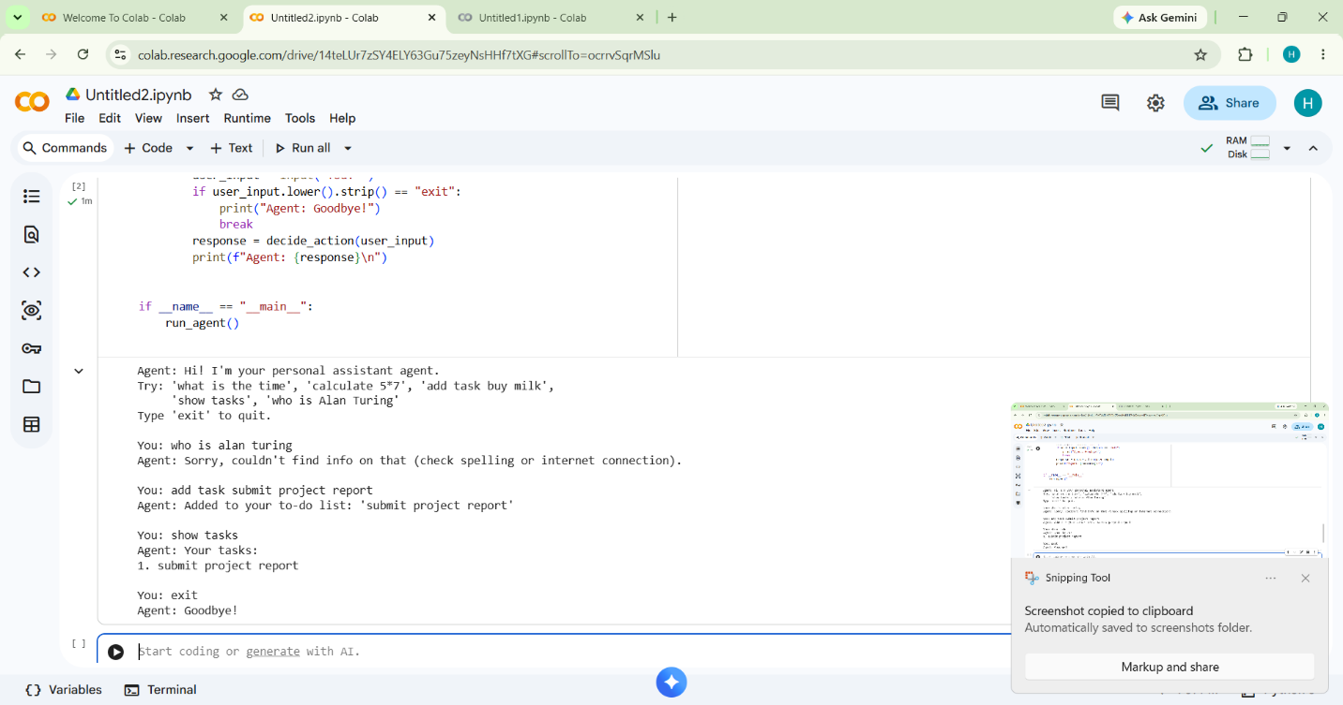

You: what is the time
Agent: Current date & time: Saturday, 27 June 2026, 05:32 PM

You: calculate 25*4
Agent: Result: 100

You: add task submit project report
Agent: Added to your to-do list: 'submit project report'

You: show tasks
Agent: Your tasks:
1. submit project report

You: who is Alan Turing
Agent: Alan Mathison Turing was an English mathematician and computer
scientist, widely considered the father of theoretical computer science...

7. Live Web Interface
To make the agent accessible to anyone without requiring Python or Colab, the same logic was re-implemented as a single-page web application (index.html) using HTML, CSS and JavaScript. It runs entirely in the browser — the four tools (calculator, date & time, to-do manager, Wikipedia search) and the decision engine are all reproduced in JavaScript, and the page visually highlights the agent's Perceive → Decide → Act → Respond pipeline live as each message is processed. The page was deployed for free using GitHub Pages.
Live Demo Link:
- No installation, Python, or API key required — works on any device with a browser
- Visualizes the agent's internal reasoning pipeline live, for demonstration purposes
- Hosted for free as a static site via GitHub Pages
[Insert a screenshot of the live webpage here]

8. Advantages
- Provides a single conversational interface for multiple everyday tasks
- Demonstrates autonomous decision-making, a core principle of AI agents
- Modular design — new tools can be added without changing existing code
- Lightweight and free — no paid API or internet-dependent model required

9. Limitations
- Uses keyword matching rather than true natural-language understanding
- Cannot reliably handle complex, ambiguous, or multi-step queries
- The to-do list is stored only in memory and resets when the program restarts

10. Future Scope
- Integrate a Large Language Model (e.g. Google Gemini) so the decision engine understands free-form natural language instead of keywords
- Add voice input/output to create a true spoken voice assistant
- Persist the to-do list using a file or database so data is saved between sessions
- Add further tools such as weather updates, email reading, or calendar integration

11. Conclusion
This project successfully demonstrates the core working principle of Agentic Artificial Intelligence through a practical, beginner-friendly Smart Personal Assistant Agent. By combining four independent tools under one autonomous decision-making engine, the system shows how an agent perceives a request, reasons about the correct action, acts using the appropriate tool, and responds — the same fundamental loop that powers advanced real-world AI agents today. The project provides a solid conceptual and practical foundation for further exploration into LLM-based agentic systems.

12. References
- Russell, S., & Norvig, P. — Artificial Intelligence: A Modern Approach
- Python Official Documentation — docs.python.org
- Wikipedia Python Library — pypi.org/project/wikipedia
- Google AI for Developers — ai.google.dev

Appendix A: Complete Source Code
"""
Smart Personal Assistant Agent — Agentic AI Mini Project
----------------------------------------------------------
This program demonstrates a simple AGENT that follows the classic
agentic loop: PERCEIVE -> DECIDE -> ACT -> RESPOND.

It has 4 "tools" it can autonomously choose between based on what
the user types, instead of running one fixed task:
1. Calculator
2. Date & Time lookup
3. To-Do list manager
4. Wikipedia search

Run it and just chat with it naturally.
"""

import datetime
import re

# ---------- Memory (agent's internal state) ----------
todo_list = []

# ---------- TOOLS the agent can use ----------

def calculator(expression):
"""Tool 1: Solve a basic math expression."""
try:
allowed = set("0123456789+-*/(). ")
if not set(expression) <= allowed or expression.strip() == "":
return "Sorry, I can only do basic math like + - * /."
return f"Result: {eval(expression)}"
except Exception:
return "Sorry, I couldn't calculate that."

def get_datetime():
"""Tool 2: Return current date and time."""
now = datetime.datetime.now()
return f"Current date & time: {now.strftime('%A, %d %B %Y, %I:%M %p')}"

def add_task(task):
"""Tool 3a: Add an item to the to-do list."""
task = task.strip()
if not task:
return "Please tell me what task to add."
todo_list.append(task)
return f"Added to your to-do list: '{task}'"

def view_tasks():
"""Tool 3b: Show the to-do list."""
if not todo_list:
return "Your to-do list is empty."
return "Your tasks:\n" + "\n".join(f"{i+1}. {t}" for i, t in enumerate(todo_list))

def search_wikipedia(query):
"""Tool 4: Look up a topic on Wikipedia."""
query = query.strip()
if not query:
return "Please tell me what to search for."
try:
import wikipedia
try:
return wikipedia.summary(query, sentences=2, auto_suggest=True)
except wikipedia.exceptions.DisambiguationError as e:
# Multiple matches found -> just use the first suggested option
return wikipedia.summary(e.options[0], sentences=2, auto_suggest=False)
except wikipedia.exceptions.PageError:
# No exact page -> fall back to a manual search first
results = wikipedia.search(query)
if results:
return wikipedia.summary(results[0], sentences=2, auto_suggest=False)
return f"Sorry, I couldn't find a Wikipedia page for '{query}'."
except Exception:
return "Sorry, couldn't find info on that (check your internet connection)."

# ---------- DECISION ENGINE (the "brain" of the agent) ----------

def decide_action(user_input):
"""
This is the agent's reasoning step: it looks at what the user said
and decides which tool is the right one to call. This is what makes
it an AGENT rather than a single-purpose script.
"""
text = user_input.lower()

if "add task" in text or "remind me to" in text:
key = "add task" if "add task" in text else "remind me to"
return add_task(text.split(key, 1)[-1])

elif "show task" in text or "my task" in text or "todo" in text or "to-do" in text:
return view_tasks()

elif any(op in text for op in ["+", "-", "*", "/", "calculate", "calc"]):
expr = re.sub(r"[^0-9+\-*/(). ]", "", text)
return calculator(expr)

elif "time" in text or "date" in text:
return get_datetime()

elif "who is" in text or "what is" in text or "search" in text:
topic = text.replace("who is", "").replace("what is", "").replace("search", "")
return search_wikipedia(topic)

else:
return ("I'm not sure how to help with that yet. Try things like:\n"
" 'what is the time'\n 'calculate 12*8'\n"
" 'add task buy milk'\n 'show tasks'\n 'who is Alan Turing'")

# ---------- AGENT LOOP ----------

def run_agent():
print("Agent: Hi! I'm your personal assistant agent.")
print("Try: 'what is the time', 'calculate 5*7', 'add task buy milk',")
print(" 'show tasks', 'who is Alan Turing'")
print("Type 'exit' to quit.\n")

while True:
user_input = input("You: ")
if user_input.lower().strip() == "exit":
print("Agent: Goodbye!")
break
response = decide_action(user_input)
print(f"Agent: {response}\n")

if __name__ == "__main__":
run_agent()

